SCIS App
https://4438133-SB3.app.netsuite.com/c.4438133_sb3/pos/main.ssp?whence=&n=2&fakewrapper=T#login

Credentials
User: scis4@grubmarket.com
Pass: Netsuite123

Transaction History -> Receipt:
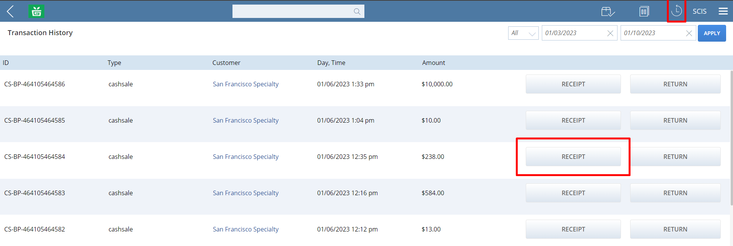
Then press “Print Receipt”:
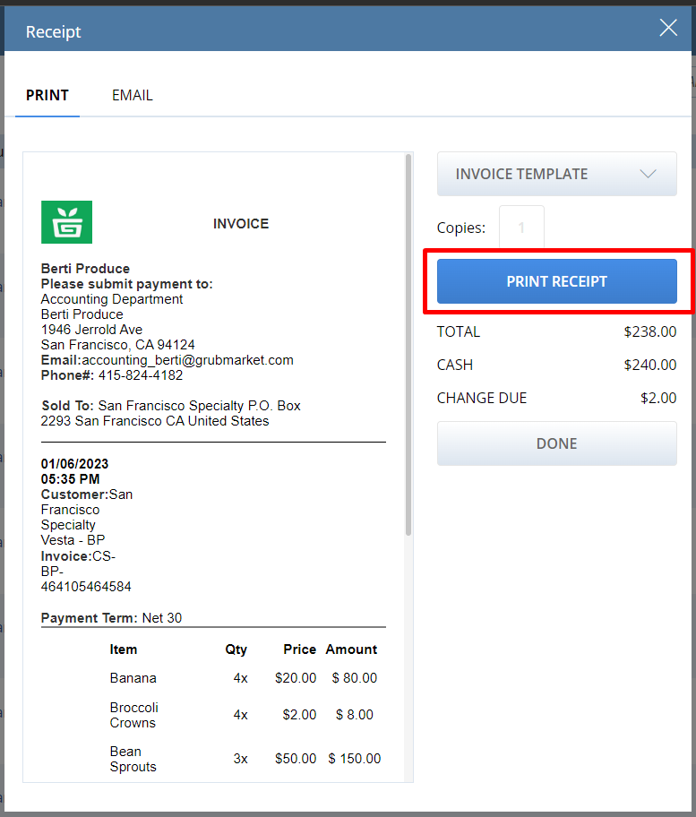
We want to modify the way it appears, they want it exactly like this:
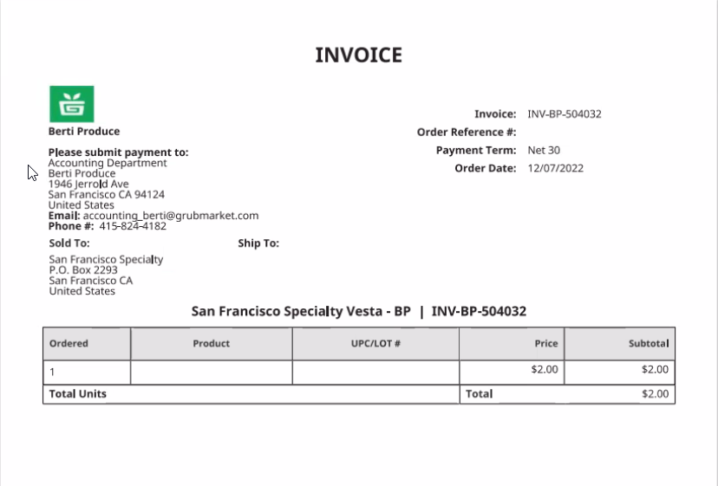
But is showing up like this:
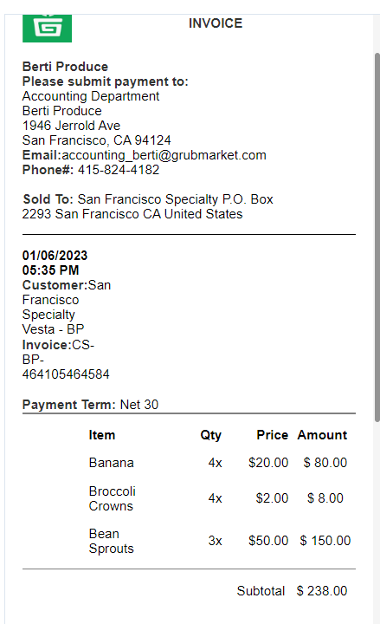

Commerce -> InStore -> Receipt Templates:
SCIS Receipt Template List -> SCIS Full Page Pick Ticket New 2 and SCIS Full Page Invoice, we have 2 options because:
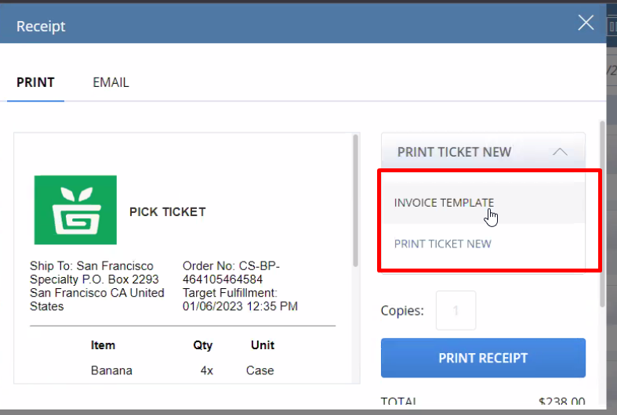
See which is the template, and then go under Customizations -> Forms -> Advanced PDF/HTML Templates: look for SCIS Full Page Pick Ticket 2 then edit that, and edit the html code.

